Lab 8: Deployment View & Quality Attribute Analysis (ATAM)
Contents
1. Cover Page 1
2. Abstract / Summary 1
3. Lab-Specific Section: Deployment View & Quality Attribute Analysis (ATAM) 1
3.1 Document 1: UML Deployment Diagram 1
3.2 Document 2: Hardware and Software Nodes Specification 3
3.3 Document 3: Communication Paths and Protocols 3
3.4 Document 4: ATAM Analysis Table 4
4. Conclusion & Reflection 5

Cover Page
• Title: Event-Driven Architecture (EDA) & Integration
• Course Info: Software Architecture
• Student Details: [NGUYEN QUE BAC], [23010574]; [HOANG TUAN KIET], [23010517]; [DO BAO LONG], [23010561]
• Date: February 01, 2026

Abstract / Summary
This report details the architectural transformation of the Cinema Management System, evolving from a traditional Monolithic Laravel application to a decoupled, event-driven microservices-oriented structure. The primary focus of this evolution was to enhance the system's ability to handle high-traffic events, such as major movie releases, and to ensure that background tasks like sending booking confirmations do not impact the core ticket purchasing flow. By implementing an API Gateway for centralized request routing and a RabbitMQ Message Broker for asynchronous notifications, we have successfully isolated the Movie and Booking logic from the Notification service. This final report evaluates the physical deployment via UML diagrams and utilizes the ATAM (Architecture Trade-off Analysis Method) to verify that the cinema system now meets critical quality attributes, specifically Scalability for peak booking times and Availability through robust fault isolation.

Lab-Specific Section: Deployment View & Quality Attribute Analysis (ATAM)

Document 1: UML Deployment Diagram
The UML Deployment Diagram visualizes the physical distribution of the Cinema Management System’s software artifacts across various execution environments. It illustrates how the Laravel-based services, the API Gateway, and the RabbitMQ message broker are mapped onto physical or virtual nodes to achieve scalability and fault isolation.
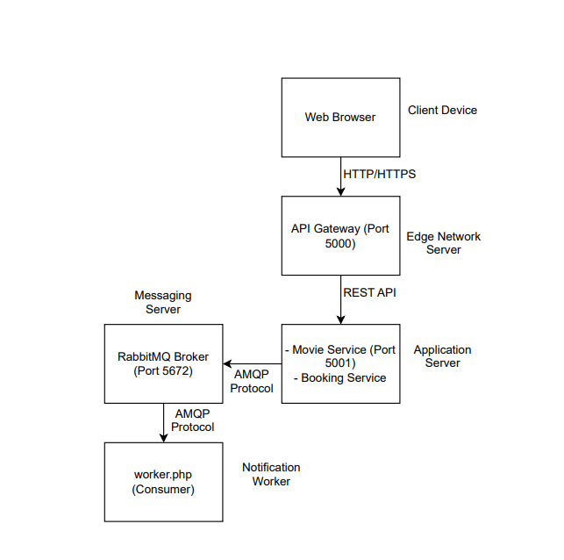
Figure 1: UML Deployment Diagram for Cinema Management System.
Node and Artifact Descriptions:
- Client Device: Represents the end-user's hardware (e.g., Laptop, Smartphone) accessing the cinema platform. The primary artifact here is the Web Browser, which renders the HTML/JavaScript interface.
- Edge Network (Gateway Server): A dedicated server node hosting the API Gateway (Port 5000). It serves as the single entry point for all external traffic, managing request routing to the internal cinema services and providing an additional layer of security.
- Application Cluster: The core execution environment where the business logic resides. It hosts multiple Laravel-based services:
  - Movie Service Artifact: Manages movie catalogs, cinema locations, and showtimes (Port 5001).
  - Booking Service Artifact: Handles seat selection, ticket pricing, and reservation logic.
- Messaging Server (Docker Container): A virtualized node running the RabbitMQ Broker (Port 5672). This node is the backbone of the system's Event-Driven Architecture (EDA), allowing the Booking Service to publish events asynchronously.
- Notification Node (Worker): A background execution environment running the worker.php script. This artifact acts as a consumer that processes messages from RabbitMQ to send booking confirmations or alerts without blocking the main user flow.
Communication Paths and Protocols:
- Client Edge Network: Utilizes HTTP/HTTPS for secure web communication over the public internet.
- Edge Network Application Cluster: Uses Internal HTTP/REST for high-speed routing between the gateway and the cinema services.
- Application Cluster Messaging Server: Employs the AMQP protocol to push event messages (e.g., Ticket_Booked) to the broker.
- Messaging Server Notification Node: Uses AMQP for reliable message delivery from the queue to the background worker.

Document 2: Hardware and Software Nodes Specification
In this monolithic phase, the Cinema Management System is organized into a Three-Tier Layered Architecture. This structure ensures a separation of concerns within a single codebase.
Layer | Responsibility | Key Components / Artifacts
Presentation Layer | Handles the user interface and captures user inputs for movie browsing and ticket booking. | movie.blade.php, booking.blade.php, CSS/JS files.
Business Logic Layer | Processes core cinema rules, such as calculating ticket prices, verifying seat availability, and managing showtimes. | MovieController.php, BookingController.php.
Data Access Layer | Manages direct interaction with the database, performing CRUD operations on movie and reservation data. | Movie.php (Model), Booking.php (Model), MySQL Database.
Implementation Details:
- Tight Coupling: All layers reside within the same Laravel project directory. The Controller directly calls the Model, and the View is tightly bound to the Controller's output.
- Synchronous Processing: Every action, including sending booking confirmation emails, is performed synchronously. For instance, a user must wait for the email server to respond before the "Booking Successful" page is fully rendered.
- Single Database: All cinema-related data is stored in a single schema, where tables for movies, users, and bookings are interlinked via foreign keys.

Document 3: Communication Paths and Protocols
To ensure seamless interaction between the distributed physical nodes of the Cinema Management System, the following communication protocols are implemented:
- HTTP/HTTPS (Public Internet): Used for the communication between the Client Device (User's Browser) and the Edge Network (API Gateway). This ensures that users can securely browse movies and select seats using standard web protocols.
- Internal HTTP/REST (Private Network): The API Gateway communicates with the Application Cluster (Movie and Booking Services) through high-speed internal RESTful calls. This path handles the routing of requests such as GET /movies or POST /bookings.
- AMQP Protocol (Asynchronous Messaging): This is a critical path for our Event-Driven Architecture. When a ticket is successfully booked, the Booking Service publishes an event to the Messaging Server (RabbitMQ) via the AMQP protocol. This allows the booking flow to complete instantly without waiting for the notification to be sent.
- AMQP (Message Consumption): The Notification Node (worker.php) maintains a persistent connection with the RabbitMQ Broker using AMQP to consume and process events from the queue in the background.
- MySQL Protocol: The Application Cluster nodes connect to the Database Server using the standard MySQL protocol to perform data persistence for movie schedules, seat availability, and transaction records.

Document 4: ATAM Analysis Table
The table below evaluates and compares the Monolithic (Layered) architecture and the Microservices (EDA) architecture based on two critical quality attribute scenarios for the Cinema Management System.
Quality Attribute | Scenario | Monolithic (Layered) Approach | Microservices (EDA) Approach
Scalability (SS1) | High traffic during a blockbuster movie release (e.g., 10,000 users booking tickets simultaneously). | To handle the load, the entire monolith must be replicated. This wastes resources on idle modules (like User Profile or Admin) just to scale the Booking function. | We can independently scale only the Booking Service and Movie Service containers. This optimizes resource usage and handles peak booking traffic more efficiently.
Availability (AS1) | The Notification Service (email server) fails or slows down during the checkout process. | Since the process is synchronous, the entire transaction might hang or fail. The user cannot see the "Success" page because the system is stuck trying to send an email. | RabbitMQ acts as a buffer. The Booking Service completes the ticket sale and places an event in the queue. The system remains 100% available for bookings even if the Notification service is down.

Conclusion & Reflection
The completion of this 8-lab series marks a successful architectural transformation of the Cinema Management System from a rigid Monolithic structure into a resilient, Event-Driven Microservices ecosystem. Through this journey, we have made a critical architectural trade-off by sacrificing the simplicity of a single-codebase development for the superior scalability and availability required by a modern cinema platform. While the initial Monolith was easier to manage, it created bottlenecks during high-traffic movie releases and lacked fault isolation. By implementing an API Gateway to centralize request routing and integrating a RabbitMQ Message Broker for asynchronous notifications, we have ensured that the core booking flow remains uninterrupted even if background services fail. This transition, although increasing operational complexity through the use of Docker and distributed services, provides a robust foundation that can independently scale specific business capabilities. Ultimately, this project has demonstrated that a well-evaluated architecture, guided by quality attribute analysis like ATAM, is essential for building software that is not only functional but also adaptable to real-world performance demands.

